June 2019 Newsletter
Junior League
Division III (top photo, ages 5-7) and Division II (middle photo, 8-11) go out with Coach Dan Stewart and assistant Chris Gregus and play two or three holes in a partner scr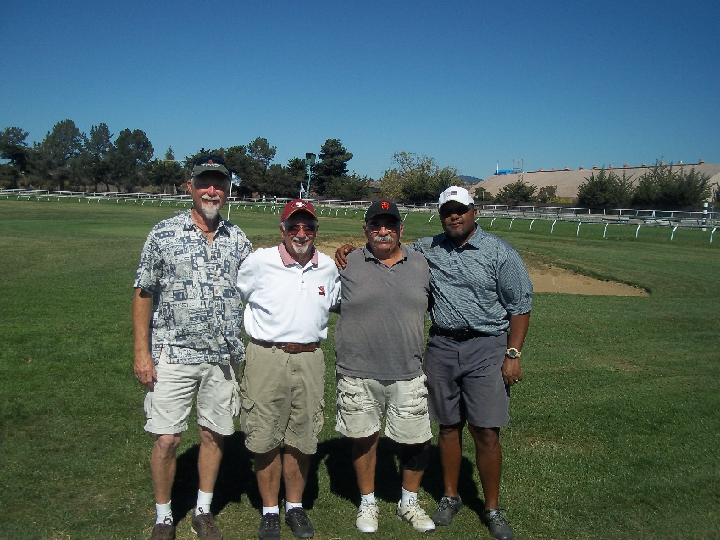amble format. Division I (lower photo, advanced groupplays nine holes ad records all their scores in an eclectic format. Before play each week, juniors go over rules, skills and core values to teach them about golf and life. Not pictured, Aiden Schuh Div. III.

Getting youngsters out on the golf course is one good way of assuring the future of the sport, and one proven way to do that is to make it more affordable for kids. The NCGA’s Youth on Course offers a program that does that.

Gena’s off to a great start . . .
Don Maiden and his 10-year-old daughter Gena, from Napa, played our course one Saturday in late April.
Gena is new to the game but anxious to learn, and her dad is dedicated to seeing that happen.
Unlike a lot of longer courses, Fairgrounds is a great place for kids learning golf and for other beginners and those trying to improve their game It's relatively short, inexpensive, you can play 9 holes in less than 2 hours . . . and our maintenance crew keeps the place in great condition.
And for youngsters like Gena, they can look into signing up with the NCGA's Youth on Course program, which offers kids outstanding savings on green fees. For instance, YOC members play 9 holes at Fairgrounds for just $1.
It only costs $18 for an annual membership. It pays for itself in a short time, and is a great way to get kids and parents playing golf. Go to the NCGA web site -- https://youthoncourse.org/ -- and find out the details, or ask us in the Pro Shop.
Summer Junior Camps: Thursday through Saturdays, June 27-29; July 11-13, July 25-27, 9 a.m.-noon. Cost $200 per junior. For details, email Head Pro Taylor Battaglia, tbattaglia@fairgroundsgolfcourse.com



Longtime Fairgrounds Club member Mark Sawyer claimed the 2019 Match Play Championship with four victories, topped off by a 5 & 4 win in the finals over Denny Spero in May.
Sawyer has two other “major” club victories and this was the second time he captured this one. “It’s hard to win four matches,” said Sawyer, noting that two of his matches went to “overtime,” the 19th hole, adding “my last match was the best. I played very consistently and didn’t make any mistakes.” For information about joining the Club, check in the Pro Shop

Worth noting . .
We get a lot of holes-in-one at Fairgrounds, but what happened Thursday, May 2, was really rare.
DJ Johnson, playing the 105-yard No. 2 hole, used a wedge to knock his tee shot in the cup for his fifth career ace.
Then Kevin Belew, playing in the same group with DJ, Donn Walters and Dennis Earnest, teed up his 58-degree wedge . . . and he knocked it in the hole, too !!!
Kevin, a caddy at Mayacama, has been playing golf for 10 years but said he has had four aces in the past 10 months.

Adult Classes: A Ladies Summer Golf Class is scheduled Wednesdays, June 26-July 24, 5-6 p.m. Cost $100 for the 5-week class; Adult Course Management Class, Wednesdays, June 26-July 24; 6:30-7:30 p.m. Cost $125 per person for 5-week class. Email Taylor to sign up or for more details: tbattaglia@fairgroundsgolfcourse.com

